ASP.NET Core 8.0 Web API
- WebApi_Handson

OBJECTIVE:
1. What is RESTful Web Service?
Answer:
A RESTful Web Service is a web service that follows the REST (Representational State Transfer) architectural style. It uses HTTP methods like GET, POST, PUT, and DELETE to perform operations on resources.

2. What is REST?
Answer:
REST (Representational State Transfer) is an architectural style used for developing web services. It allows communication between client and server using standard HTTP protocols.

3. What are the features of REST architecture?
Answer:
- Stateless communication
- Client-Server architecture
- Uniform Interface
- Resource-based URLs
- Cacheable responses
- Uses standard HTTP methods (GET, POST, PUT, DELETE)

4. What is Statelessness in REST?
Answer:
Stateless means every client request contains all the information needed to process it. The server does not store client session information.

5. What is a Web API?
Answer:
A Web API is an application programming interface that enables communication between applications over HTTP using standard HTTP methods.

6. What is a Microservice?
Answer:
A Microservice is a small, independent service that performs a specific business function and communicates with other services through APIs.

7. What is the difference between Web Service and Web API?
Web Service | Web API
Uses SOAP or REST | Mainly uses REST
Mostly returns XML | Returns JSON, XML, etc.
More complex | Lightweight and faster
Protocol dependent | Uses HTTP

8. Why is Web API preferred over Web Service?
Answer:
- Faster
- Lightweight
- Supports JSON
- Easy to consume by web and mobile applications
- Better performance

9. What is an HTTP Request?
Answer:
An HTTP Request is a message sent by the client to the server requesting data or performing an operation.

10. What is an HTTP Response?
Answer:
An HTTP Response is the message returned by the server to the client containing the requested data and status code.

11. What are Action Verbs in Web API?
Answer:
Action verbs are HTTP methods used to perform CRUD operations.
They are:
- GET
- POST
- PUT
- DELETE

12. What is the GET method?
Answer:
GET is used to retrieve data from the server.
Example:
GET /api/values

13. What is the POST method?
Answer:
POST is used to insert or create new data on the server.
Example:
POST /api/values

14. What is the PUT method?
Answer:
PUT is used to update existing data.
Example:
PUT /api/values/1

15. What is the DELETE method?
Answer:
DELETE is used to remove data from the server.
Example:
DELETE /api/values/1

16. What are HTTP Status Codes?
Answer:
HTTP Status Codes indicate the result of an HTTP request.

17. Explain HTTP Status Code 200 OK.
Answer:
The request was processed successfully.

18. Explain HTTP Status Code 400 Bad Request.
Answer:
The request sent by the client is invalid.

19. Explain HTTP Status Code 401 Unauthorized.
Answer:
The client is not authorized to access the requested resource.

20. Explain HTTP Status Code 500 Internal Server Error.
Answer:
An unexpected error occurred on the server.

21. What is a Controller in Web API?
Answer:
A Controller is a class that receives HTTP requests, processes them, and returns HTTP responses.
Example:
public class ValuesController : ControllerBase
{
}

22. Why does Controller inherit from ControllerBase?
Answer:
ControllerBase provides the basic functionality required for Web APIs, such as handling HTTP requests and returning responses, without MVC view support.

23. What is an Action Method?
Answer:
An Action Method is a public method inside a controller that handles an HTTP request.
Example:
[HttpGet]
public IEnumerable<string> Get()
{
return new string[] { "value1", "value2" };
}

24. What are Configuration Files in ASP.NET Core Web API?
Answer:
Common configuration files are:
- Program.cs
- appsettings.json
- launchSettings.json

25. What is Program.cs?
Answer:
Program.cs is the entry point of the ASP.NET Core application. It configures services, middleware, routing, and starts the application.

26. What is Dependency Injection?
Answer:
Dependency Injection (DI) is a design pattern that provides required services or objects to a class instead of creating them manually. It improves code reusability, maintainability, and testing.

27. What is appsettings.json?
Answer:
appsettings.json stores application configuration such as database connection strings, logging settings, and custom application settings.

28. What is launchSettings.json?
Answer:
launchSettings.json defines how the application starts during development, including URLs, ports, environment variables, and launch profiles.

29. What is RouteConfig in .NET Framework 4.5?
Answer:
RouteConfig.cs is used in ASP.NET MVC (.NET Framework) to define URL routing patterns.

30. What is WebApiConfig in .NET Framework 4.5?
Answer:
WebApiConfig.cs configures routing specifically for Web API applications in .NET Framework 4.5.

31. What response format does Web API support?
Answer:
Web API supports multiple response formats, including:
- JSON (most commonly used)
- XML
- Plain text (if configured)

32. Why is JSON preferred in Web API?
Answer:
JSON is lightweight, easy to read, language-independent, and faster to parse than XML, making it ideal for web and mobile applications.

33. What was the output of your Web API experiment?
Answer:
The GET request returned:
[
"value1",
"value2"
]

- First Web Api using .Net core

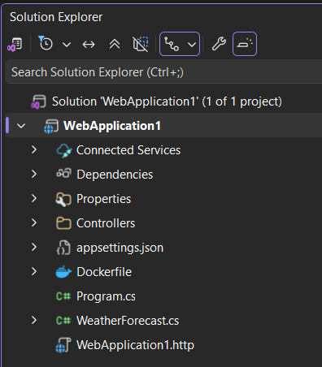
Project created

ValuesController.cs
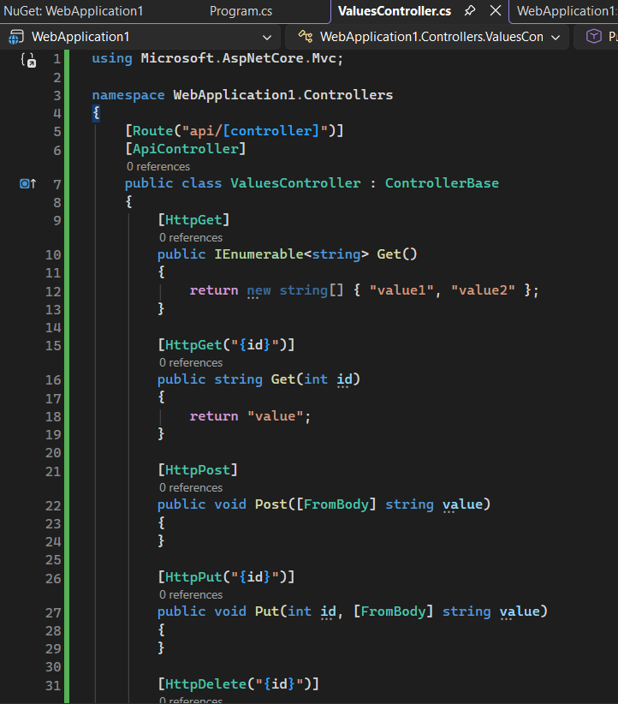

Program.cs
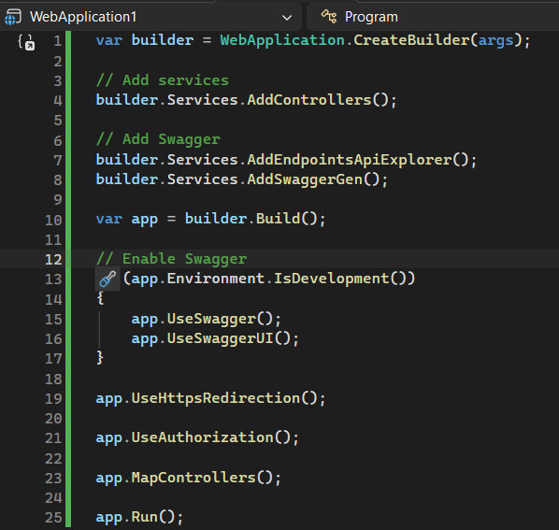

Application running (terminal/output)
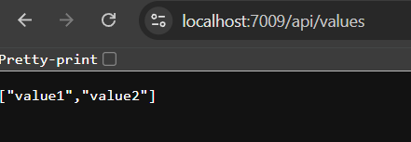

Browser output showing

